Faculty of Engineering and Computer Science
Department of Mechanical Engineering



ENGR-391 Numerical methods for Engineers

Student’s Name:

I.D.:

Duration 3 hours

PROBLEM 1 [Solving Nonlinear Equations] [20 marks]

1. Practice

Solve the following nonlinear equation using the secant method with x₀=0.5 and x₁=0.4:

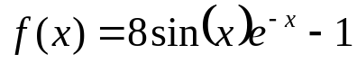

Use 3 iterations. Check your result and discuss.

2. Theory

- Discuss the difference between bracketing and open methods for root location
- Sketch the bisection and the Newton-Raphson method.

PROBLEM 2 [Solving Systems of Linear Equations] [40 marks]

- Practice

Solve the following system of linear equations:

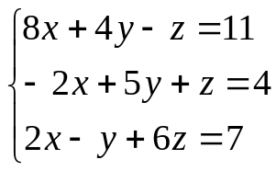

- Using LU decomposition
- Using Gauss-Seidel method (3 iterations), choose as initial guesses: y=z=0
- Check your results
- Compare the two methods

- Theory

- Show graphically an example of an ill conditioned system
- What is a lower-diagonal matrix?
- When two rows are interchanged in [A], then the determinant of the new matrix is the same as det[A]?
True / I really do not know / False

PROBLEM 3 [Numerical Integration] [20 marks]

  - Practice

Compute the following integral:

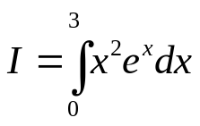
Using multi-segment Simpson’s (1/3) rule with four segments (n=4).

2. Theory

- In general, for the same number of segments, Simpson’s rule is less accurate than the trapezoidal rule?
True / I really do not know / False
- Explain shortly what is the idea behind the Gauss-Quadrature formulas.
- Improper integrals (integrals with at least one limit equal to infinity) can not be
computed with numerical algorithms.
True / I really do not know / False
- To increase the accuracy of the computation of an integral using a quadrature formula, one has normally to reduce the step-size (increase the number of segments for a multi-segment version of the quadrature formula). What do you think about the following statement:
The accuracy of my result is only limited by the computation time, i.e, with a computer; you will be able to increase the number of segments and to more accurately predict the value of the integral?
True / I really do not know / False
Explain why (even for I really do not know)?

PROBLEM 4 [Solving Ordinary Differential Equations] [20 marks]

1. Practice

Solve the following ODE:

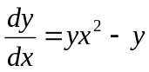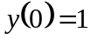

Using Runge-Kutta second order method (with Heun’s method), for 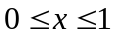 and a step of 0.25.

2. Theory

- Euler’s method can be considered as the first order Runge-Kutta method?
True / I really do not know / False
- What is the difference between a boundary-value problem and an initial- value problem?

